WRITTEN PERMISSION FOR AN UNRELATED APPLICABLE ADULT TO TRAVEL TO COMPETITION ALONE WITH MINOR ATHLETE
CUMBERLAND VALLEY AQUATIC CLUB
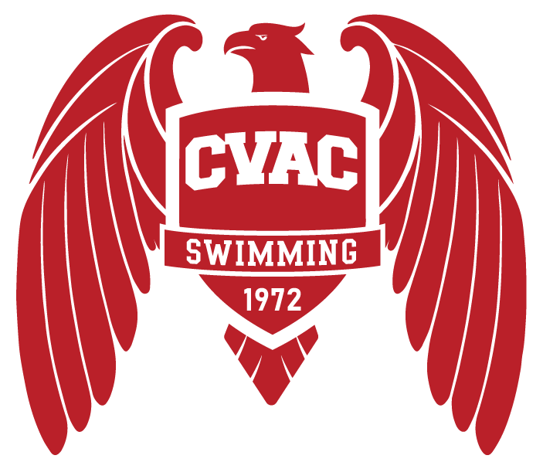

I, , legal guardian of , a minor athlete, give express written permission, and grant an exception to the Minor Athlete Abuse Prevention Policy for (minor athlete), to travel with (Applicable Adult), to travel from (point of origin) to (destination) to attend the (name of competition)
from to (dates of travel to competition).
I acknowledge that (minor athlete) cannot share a hotel room, sleeping arrangement or other overnight lodging location with (Applicable Adult) at any time. I further acknowledge that this written permission is valid only for the dates and location specified herein.

Legal Guardian Signature:
Date:

WRITTEN PERMISSION FOR A LICENSED MASSAGE THERAPIST OR OTHER CERTIFIED PROFESSIONAL OR HEALTH CARE PROVIDER TO TREAT A MINOR ATHLETE
CUMBERLAND VALLEY AQUATIC CLUB

I, , legal guardian of , a minor athlete, give express written permission, and grant an exception to the Minor Athlete Abuse Prevention Policy for (massage therapist or other certified professional) to provide a massage, rubdown and/or athletic training modality on
(minor athlete) on (date)
at (location). The massage, rubdown or athletic training modality must be done with at least one other adult present in the room and must never be done with only (minor athlete) and (massage therapist or other certified professional) in the room. I acknowledge that I have the right to observe the massage, rubdown or athletic training modality. I further acknowledge that this written permission is valid only for the dates and location specified herein.

Legal Guardian Signature:
Date:

WRITTEN PERMISSION FOR AN UNRELATED ADULT ATHLETE TO SHARE THE SAME HOTEL, SLEEPING ARRANGEMENT OR OVERNIGHT LODGING LOCATION WITH MINOR ATHLETE
CUMBERLAND VALLEY AQUATIC CLUB

I, , legal guardian of , a minor athlete, give express written permission, and grant an exception to the Minor Athlete Abuse Prevention Policy for (minor athlete), to stay in the same hotel room of, or share a sleeping arrangement or other overnight lodging location
with (unrelated adult athlete)
at (location of hotel room or other overnight lodging location) from to (dates of applicable rooming arrangement). I further acknowledge that this written permission is valid only for the dates and location specified herein.

Legal Guardian Signature:
Date:

WRITTEN PERMISSION FOR AN UNRELATED APPLICABLE ADULT TO PROVIDE LOCAL TRANSPORTATION TO MINOR ATHLETE
CUMBERLAND VALLEY AQUATIC CLUB

I, , legal guardian of , a minor athlete, give express written permission, and grant an exception to the Minor Athlete Abuse Prevention Policy for , an unrelated Applicable Adult to provide local vehicle transportation to (minor athlete) to (destination) on (date(s))
at (approximate time), and further acknowledge that this written permission is valid only for the transportation on the specified date and to the specified location.

Legal Guardian Signature:
Date:

